Lecture 16: Hypertext Transfer Protocol (HTTP) II

Objectives:
- Learn about classes in C# that simplify the creation of HTTP Clients
- Learn how to pass a HTTP request through a proxy server
- Learn how to write a simple Http Server

1. The WebClient Class

We saw in lecture 15, how to use the TcpClient class to create a HTTP client.

To create a HTTP server, we use the TcpListener or Socket class.

In addition, C# provides a number of classes in the System.Net namespace that simplify the creation of HTTP clients. The simplest of these classes is the WebClient class.

The following are some of the properties and methods of the WebClient class.

Properties
Credentials | Gets or sets the network credentials used to authenticate the request with the Internet resource.
Headers | Gets or sets a collection of header name/value pairs associated with the request.
ResponseHeaders | Gets a collection of header name/value pairs associated with the response.

Methods
byte[] DownloadData(string uri); | Downloads data from a resource with the specified URI.
void DownloadFile(string uri, string fileName); | Downloads data from a resource with the specified URI to a local file.
Stream OpenRead(string uri); | Opens a readable stream for the data downloaded from a resource with the specified URI.
Stream OpenWrite(string uri);  Stream OpenWrite(string uri, string method); | Opens a stream for writing data to a resource with the specified URI.
byte[] UploadData(string uri, byte[] data);  byte[] UploadData(string uri, string method, byte[] data); | Uploads a data buffer to a resource with the specified URI.
byte[] UploadFile(string uri, string fileName);  byte[] UploadFile(string uri, string method, string fileName); | Uploads a local file to a resource with the specified URI.

The following example shows how to use the WebClient class:

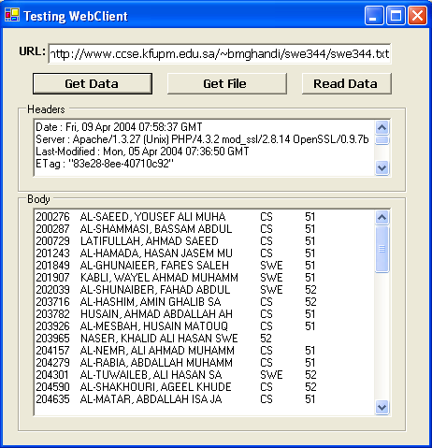

private WebClient client;
public WebClientExample()
{
InitializeComponent();
client = new WebClient();
}

void OnGetData(object sender, System.EventArgs e)
{
try {
byte[] data = client.DownloadData(urlBox.Text);
resultBox.Text = Encoding.ASCII.GetString(data);
ShowHeaders();
}
catch (WebException ex) {
MessageBox.Show(ex.Message, "Exception");
}
}

void OnGetFile(object sender, System.EventArgs e)
{
try {
string fname = urlBox.Text.Substring(urlBox.Text.LastIndexOf("/")+1);
client.DownloadFile(urlBox.Text, fname);
resultBox.Text = "File Downloaded";
ShowHeaders();
}
catch (WebException ex) {
MessageBox.Show(ex.Message, "Exception");
}
}

void OnReadData(object sender, System.EventArgs e)
{
try {
StreamReader reader = new StreamReader(client.OpenRead(urlBox.Text));
String line;
resultBox.Text = "";
while ((line=reader.ReadLine())!= null)
resultBox.Text += line + "\r\n";
reader.Close();
ShowHeaders();
}
catch (WebException ex) {
MessageBox.Show(ex.Message, "Exception");
}
}

void ShowHeaders() {
WebHeaderCollection whc = client.ResponseHeaders;
headerBox.Text = "";
for(int i=0; i<whc.Count; i++) {
headerBox.Text += whc.GetKey(i) + " : " + whc.Get(i) + "\r\n";
}
}

2. The NetworkCredential class

Some web-servers do not allow anonymous access for some resources. For such servers, an instance of the NetworkCredential class is created and assigned to the Credentials property of the WebClient instance before sending the request.

The NetworkCredential class has the following constructors:

NetworkCredential();
NetworkCredential(string userName, string password);
NetworkCredential(string userName, string password, string domain);

It also has properties: Domain, Password and UserName.

- The WebRequest, WebResponse and related classes.

For more advanced HTTP client applications, the WebRequest and WebResponse classes should be used.

These classes provide more methods and properties for manipulating the headers, including a Proxy property, which is used to specify a proxy server.

However, the WebRequest and WebResponse are abstract classes. To create objects, their subclasses are used depending on the type of the URI.

The subclasses of WebRequest are HttpWebRequest and FileWebRequest.

Similarly, WebResponse has HttpWebResponse and FileWebResponse as concrete subclasses.

The following are some of the properties and methods of the HttpWebRequest class:

Properties
Accept | Gets or sets the value of the Accept HTTP header.
Address | Gets the URI of the Internet resource that actually responds to the request.
AllowAutoRedirect | Gets or sets a value that indicates whether the request should follow redirection responses.
ClientCertificates | Gets the collection of security certificates associated with this request.
Connection | Gets or sets the value of the Connection HTTP header.
ContentLength | Gets or sets the Content-length HTTP header.
ContentType | Overridden. Gets or sets the value of the Content-type HTTP header.
Credentials | Overridden. Provides authentication information for the request.
HaveResponse | Gets a value indicating whether a response has been received from an Internet resource.
Headers | Gets a collection of the name/value pairs that make up the HTTP headers.
IfModifiedSince | Gets or sets the value of the If-Modified-Since HTTP header.
KeepAlive | Gets or sets a value indicating whether to make a persistent connection to the Internet resource.
MediaType | Gets or sets the media type of the request.
Method | Gets or sets the method for the request.
Pipelined | Gets or sets a value indicating whether to pipeline the request to the Internet resource.
ProtocolVersion | Gets or sets the version of HTTP to use for the request.
Proxy | Gets or sets proxy information for the request.
SendChunked | Gets or sets a value indicating whether to send data in segments to the Internet resource.
UserAgent | Gets or sets the value of the User-agent HTTP header.

Methods
Abort | Cancels a request to an Internet resource.
BeginGetRequestStream | Begins an asynchronous request for a Stream instance to use to write data.
BeginGetResponse | Begins an asynchronous request to an Internet resource.
EndGetRequestStream | Ends an asynchronous request for a Stream instance to use to write data.
EndGetResponse | Ends an asynchronous request to an Internet resource.
GetRequestStream | Gets a Stream instance to use to write request data.
GetResponse | Returns a response from an Internet resource.

- WebProxy and GlobalProxySelection classes

To communicate through a proxy, an instance of the WebProxy class must be created.

The proxy instance is assigned to the Proxy property of the WebRequest instance or assigned globally using the GlobalProxySelection class.

The most complete version of the WebProxy constructor has the following form:

public WebProxy(string Address, bool BypassOnLocal, string[] BypassList, ICredentials Credentials);

The GlobalProxySelection class is used to define a default proxy which all instances of Web Request will use. It has a property, Select, which is assigned the WebProxy instance.

Notice that GlobalProxySelection class can also be used with the WebClient class.

Example:
The following example shows a HTTP client, which can be used to communicate with servers even beyond the local network.
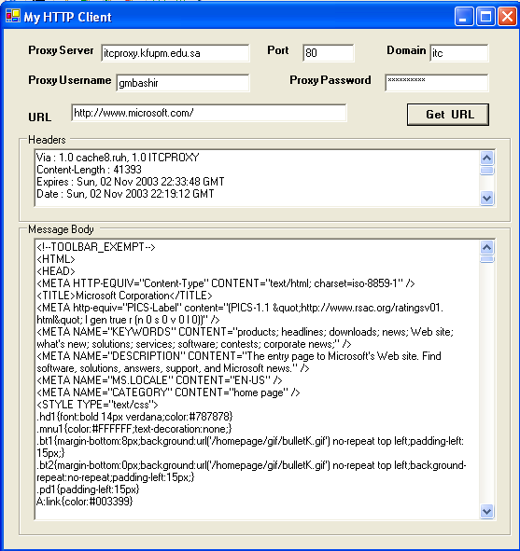

void OnGetUrlClicked(object sender, System.EventArgs e)
{
headerBox.Text = "";
resultBox.Text = "";
NetworkCredential myCred = null;
WebProxy proxyObject = null;

if ( proxyPasswordBox.Text != "")
{
myCred = new NetworkCredential(proxyUsernameBox.Text,
proxyPasswordBox.Text, proxyDomainBox.Text);
proxyObject= new WebProxy(proxyServerBox.Text+":"+proxyPortBox.Text,
true,null, myCred);
//GlobalProxySelection.Select = proxyObject;
}

if (!hasProtocol(urlBox.Text))
urlBox.Text = "http://"+ urlBox.Text;

//if no file name is given append slash
if (urlBox.Text.LastIndexOf('/') == urlBox.Text.LastIndexOf("//")+1)
urlBox.Text +="/";

WebHeaderCollection whc;
WebResponse result = null;
try {
WebRequest req = WebRequest.Create(urlBox.Text);
if (proxyObject != null)
req.Proxy = proxyObject;
result = req.GetResponse();
Stream rs = result.GetResponseStream();
StreamReader sr = new StreamReader(rs);
resultBox.Text=sr.ReadToEnd();

whc = result.Headers;
for (int i=0; i<whc.Count; i++) {
headerBox.Text += whc.GetKey(i) + " : " + whc.Get(i) + "\r\n";
}
result.Close();
}
catch(Exception) {
resultBox.Text = "Exception has occured";
}
}

private bool hasProtocol(string s) {
return s.IndexOf("//") != -1;
}

- Creating a Http Server

Although there are a number of classes specifically designed to help create Http clients, there are no such helper classes for creating Http Servers.

Like any TCP server, a http server is created using the TcpListener class or using the Socket class.

The following example shows a simple Http 1.0 server that supports only the GET method.

using System;
using System.Collections;
using System.IO;
using System.Net;
using System.Net.Sockets;
using System.Threading;

class SimpleHttpServer {
static int count = 0;

public static void Main(string[] args)
{
string docFolder = Directory.GetCurrentDirectory();
int portNumber = 8080;
TcpListener tcpListener = new TcpListener(IPAddress.Any, portNumber);
tcpListener.Start();

Console.WriteLine("Waiting for a connection on port 8080 ... ");

while (true)
{
TcpClient client = tcpListener.AcceptTcpClient();
Console.WriteLine("Visitor Count: "+ (++count));
ConnectionHandler handler = new ConnectionHandler(client);
ThreadPool.QueueUserWorkItem(new WaitCallback(handler.HandleConnection), docFolder);
}
}
}

class ConnectionHandler
{
TcpClient client;
NetworkStream stream;
StreamReader reader;
StreamWriter writer;
string docFolder;
string request;

public ConnectionHandler(TcpClient client) {
this.client = client;
stream = client.GetStream();
reader = new StreamReader(stream);
writer = new StreamWriter(stream);
}

public void HandleConnection(Object state) {
docFolder = (string) state;

request = reader.ReadLine(); //read the request;

string input;
//read rest of the request
while ((input = reader.ReadLine()).Length != 0);

string[] token = request.Split(' ');
if (token.Length == 3 && token[0] == "GET" &&
token[1].StartsWith("/") && token[2].StartsWith("HTTP")) {

string fileName = token[1].Replace('/', '\\');
fileName = docFolder + fileName;
if (File.Exists(fileName)) {
writer.Write("HTTP/1.0 200 OK\r\n"); //send response line
SendHeaders(fileName);
SendFile(fileName);
}
else
WriteError(404, "Not Found");
}
else {
WriteError(400, "Bad Request");
}
stream.Close();
client.Close();
}

public void WriteError(int status, string message) {
writer.Write("HTTP/1.0 " + status + " " + message + "\r\n");
writer.Write("\r\n");
writer.Flush();
}

public void SendHeaders(string fileName) {
FileInfo file = new FileInfo(fileName);
writer.Write("Content-Length: " + file.Length + "\r\n");
writer.Write("\r\n"); //blank line here!
writer.Flush(); //need to flush the headers
}

public void SendFile(string fileName) {
FileStream file = new FileStream(fileName, FileMode.Open, FileAccess.Read, FileShare.Read);

byte[] data = new byte[4096];
while (file.Position < file.Length) {
int read = file.Read(data, 0, data.Length);
stream.Write(data, 0, read);
}
stream.Flush();
file.Close();
}
}

